Algorithm and Datastructures:

Chapter 1: Introduction

1. Analysis of Algorithm:

We use asymptotic analysis, to measure order of growth of a program in-terms of input size.

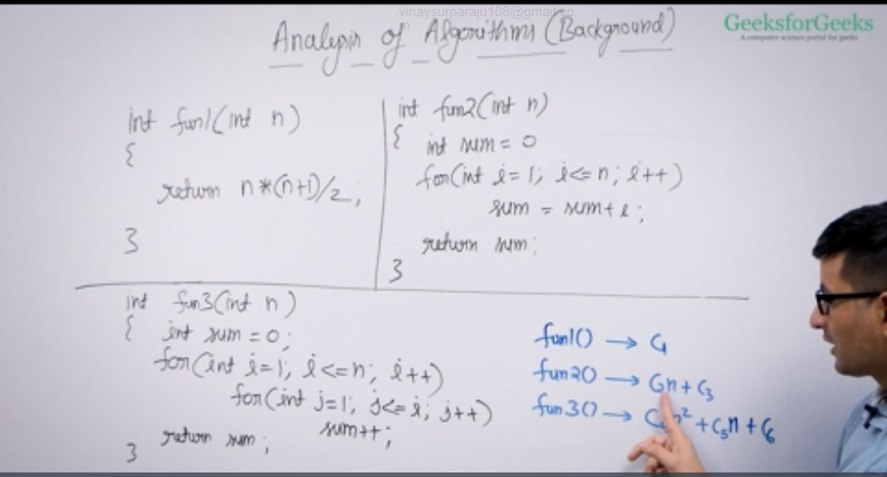

The first function does the constant work for the input.

The second function does the n times + constant work for the input.

The third function does the quadratic times + constant work for the input

When we do analysis of algorithm, we always talk about input size N greater than or equal to 0 and time taken by the function T will always be greater than or equal to 0

We consider the first quadrant in 2D quadrant system

We always consider order of growth of both the functions to compare the performance between the functions and for large input value N, where N tends to infinite as per asymptotic notation.

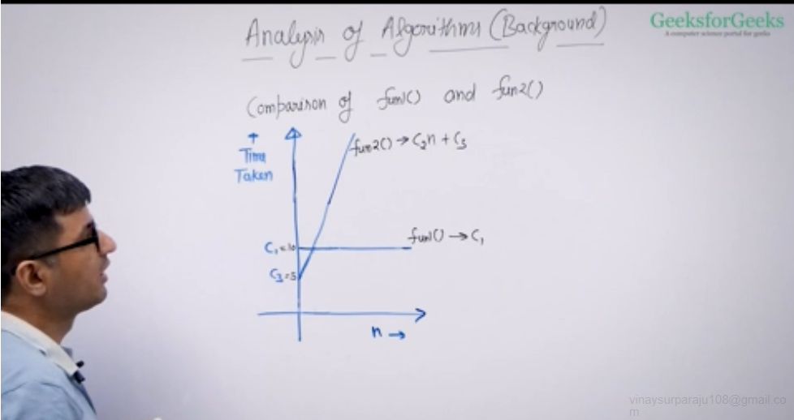

After certain value of N, in the above, fun(2) takes more time than fun(1).

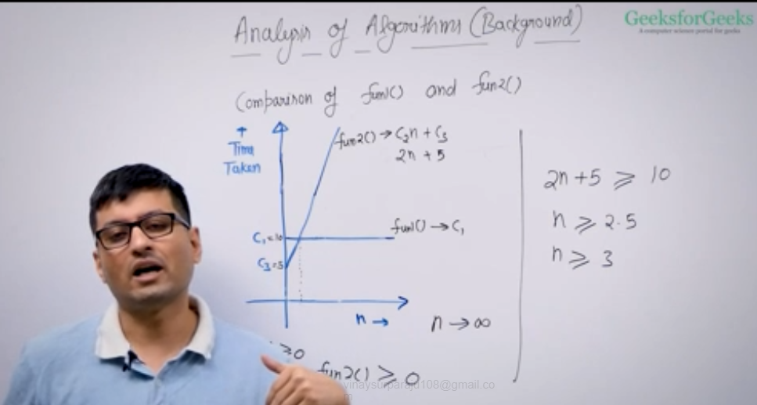

Constants will matter , but when N tends to infinite, we don’t consider constant values.

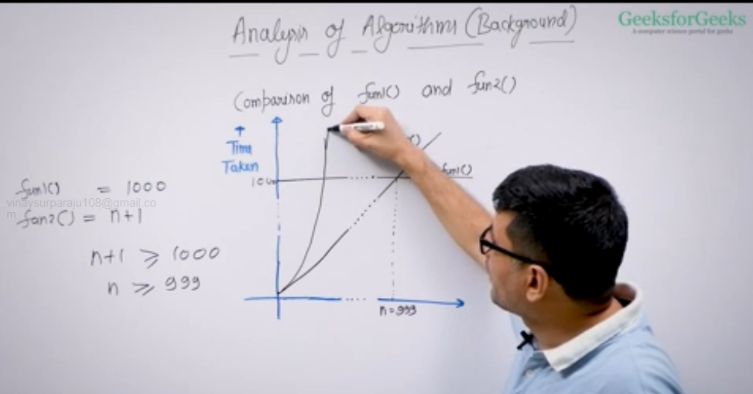

1. Order of Growth:

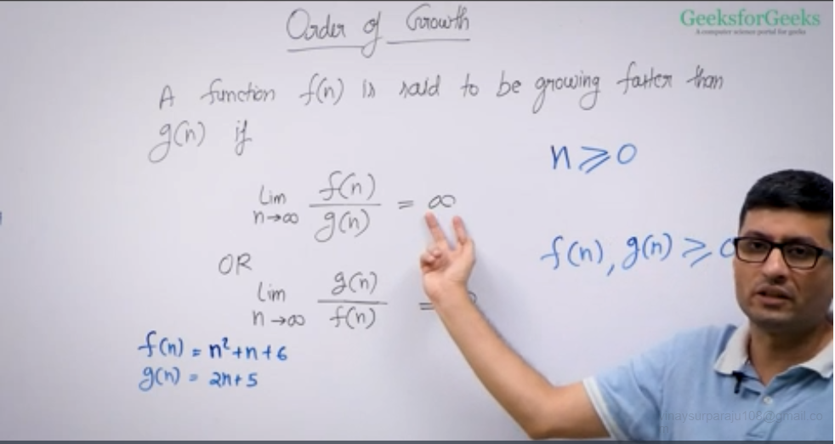

Here f(n) represents bad algorithm since it takes more time than g(n).

To calc order of growth, we divide numerator and denominator by highest order term.

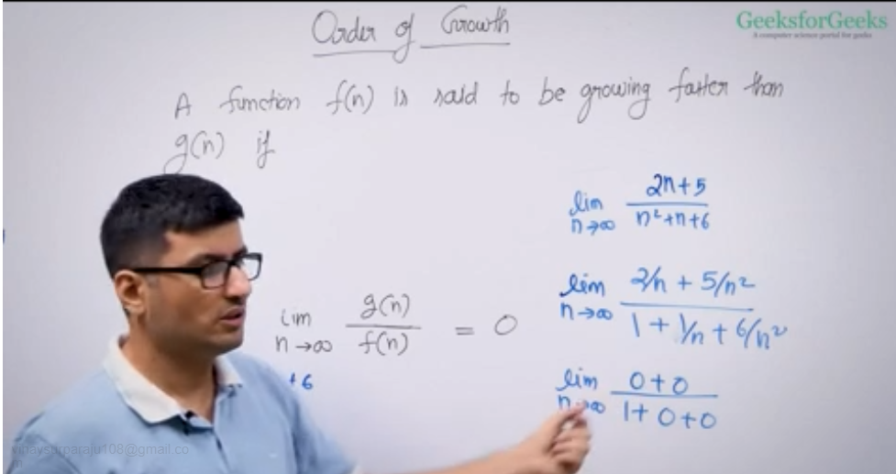

Direct way of determining order of growth:

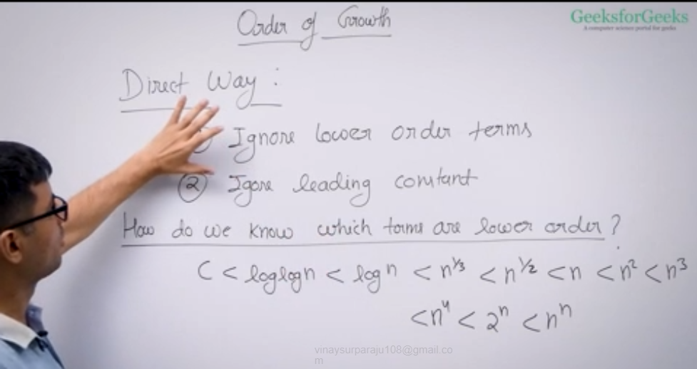

Eg:

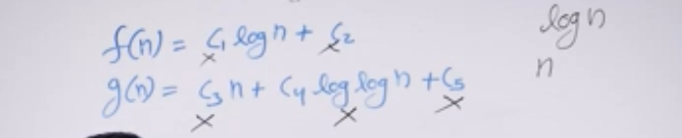

f(n) is better algorithm compared to g(n).

Asymptotic Notation:

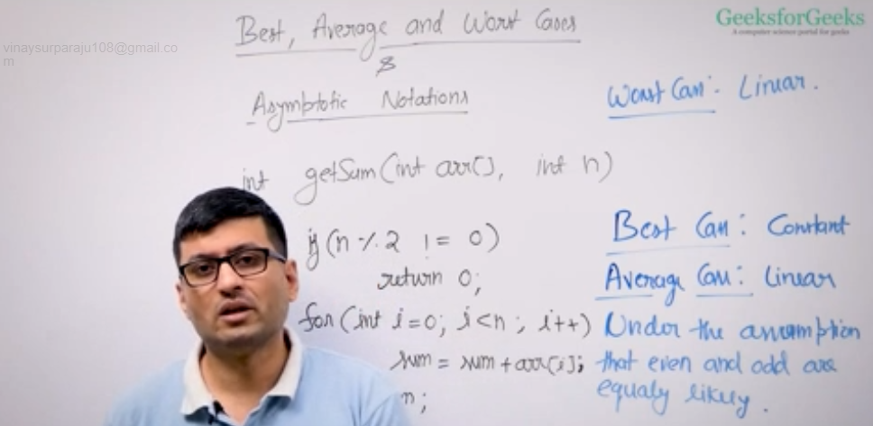

In the eg: When n is odd, O(n) will be constant under best case scenario.. Average case will be linear and Worst case will be linear.

Mathematical notations-

These notations are used to represent order of growth for a function and most widely used is Big O notation.

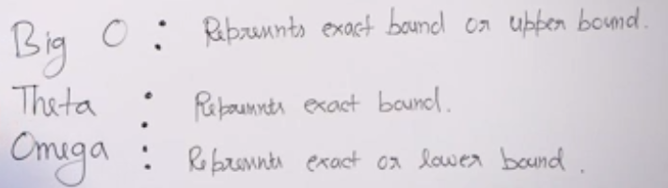

Big O notation:

We can quickly find order of growth using direct way in big O notation

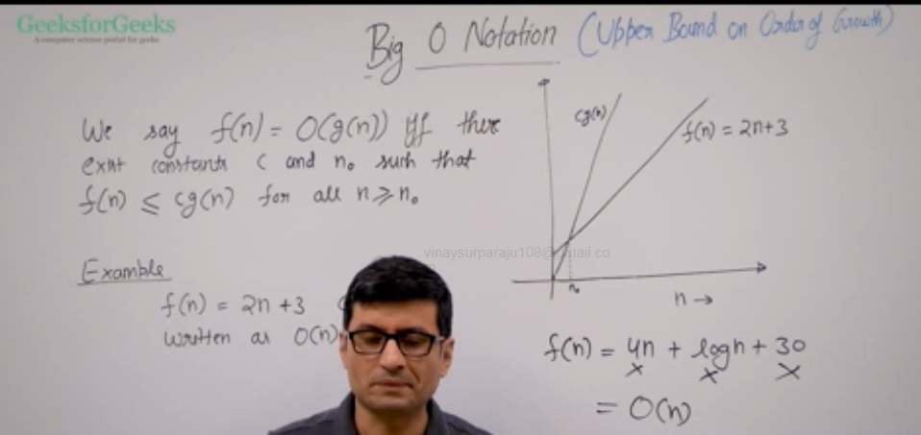

We want to find g(n) which is always going to be greater than or equal to f(n) when multiplied with constant and for large values of n >no.

We can take constant value C equal to highest order constant term +1.

We ignore lower order terms and leading constants to determine order of growth.

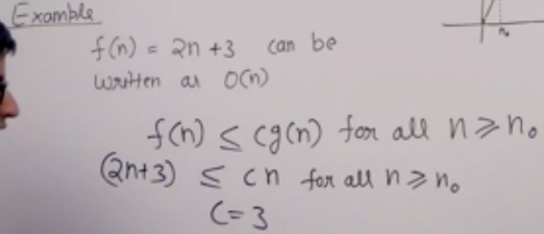

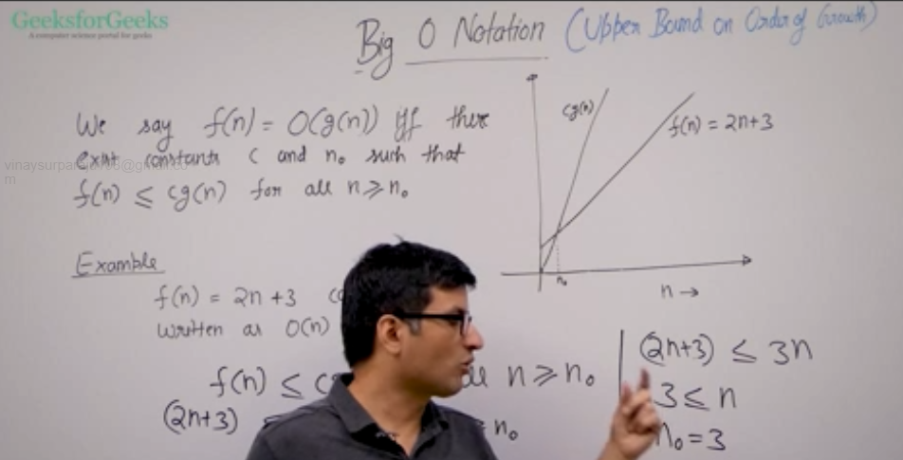

Eg:

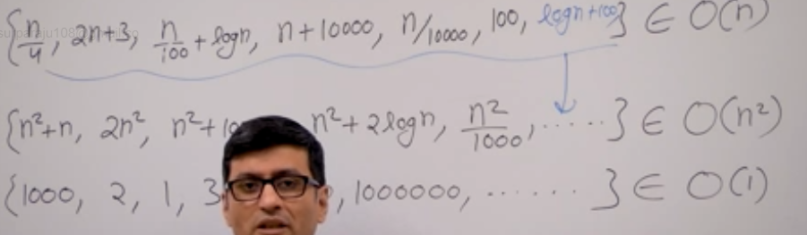

Omega Notation:

It is the opposite of Big O, it provides lower bound

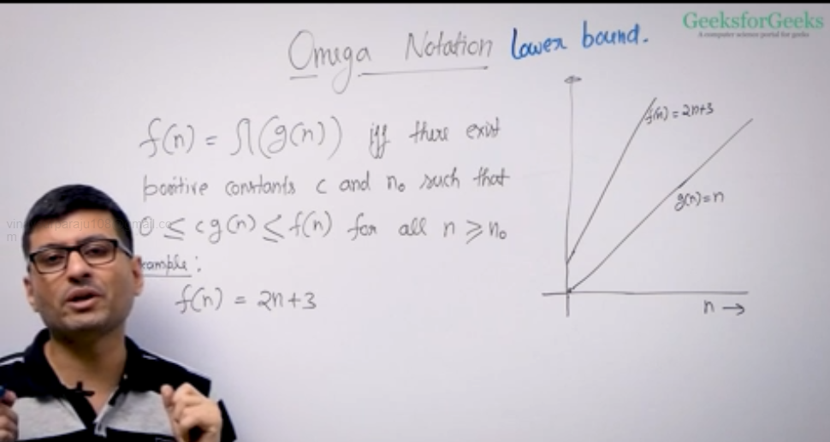

For the constant value, we will consider the leading constant and decrement by 1.

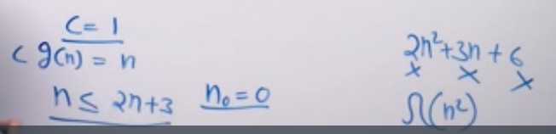

Omega(n) covers any order of growth which is greater than or equal to n bcoz it bounds from the lower end.

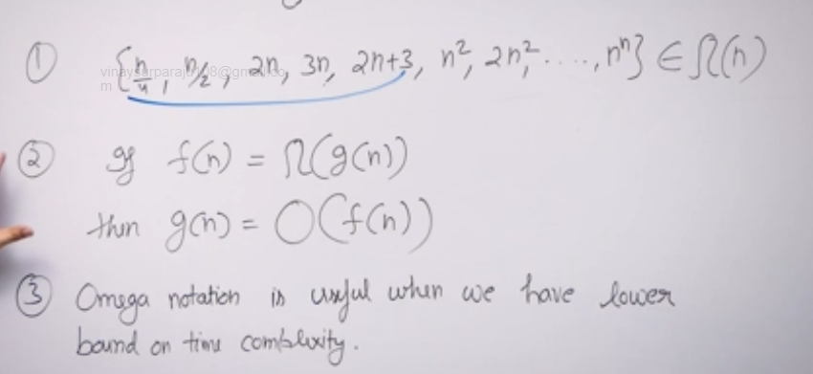

Theta Notation:

Bounds a function from both upper and lowe side, it represents exact order of growth

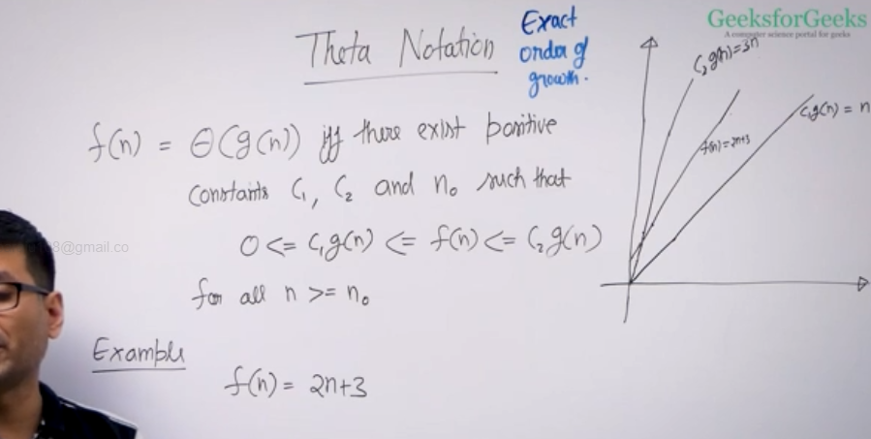

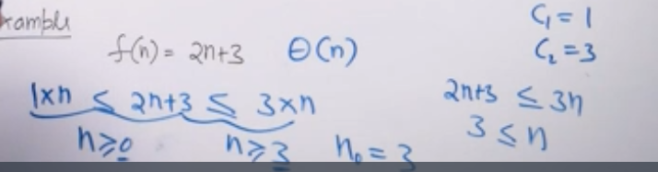

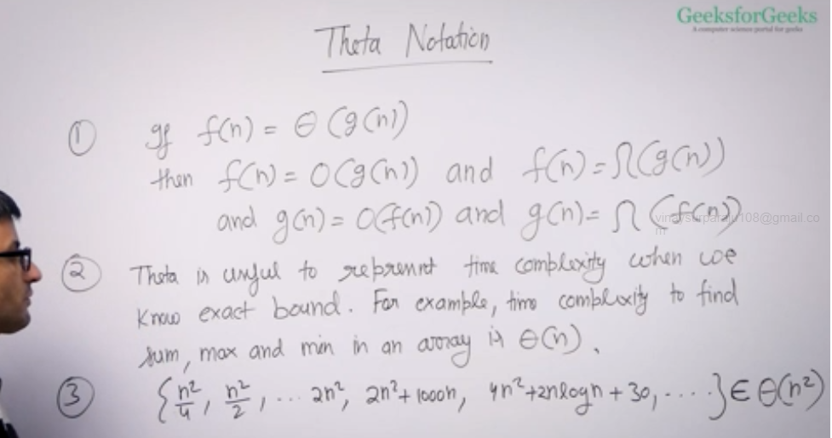

Theta notation is good to use and should be used if we know the exact bound.

Analysis of common loops:

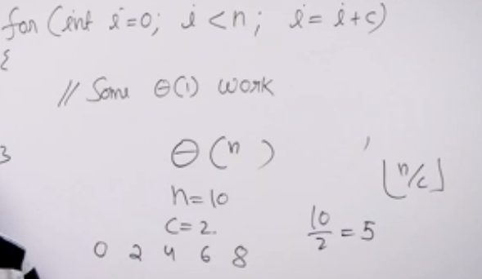

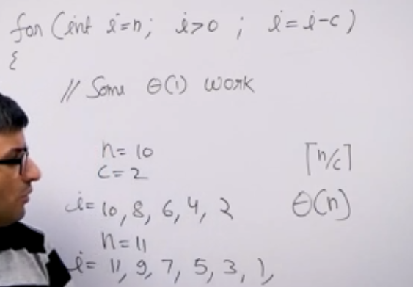

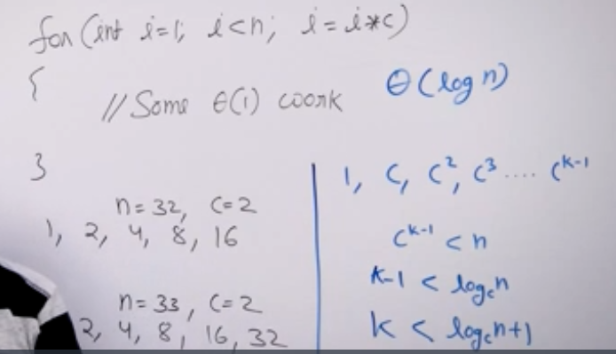

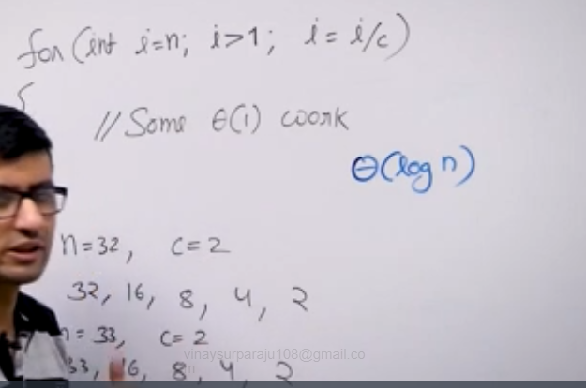

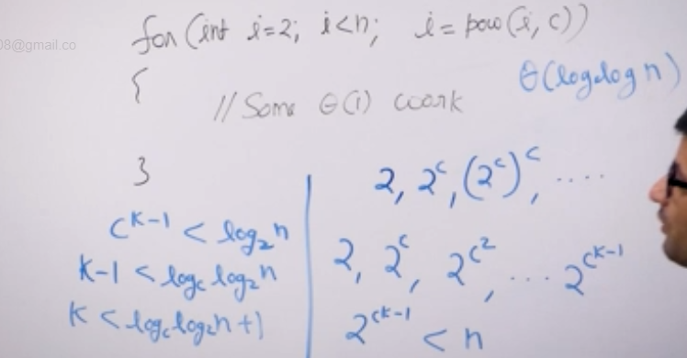

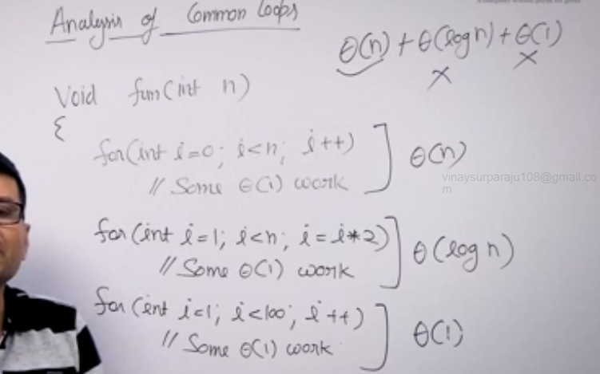

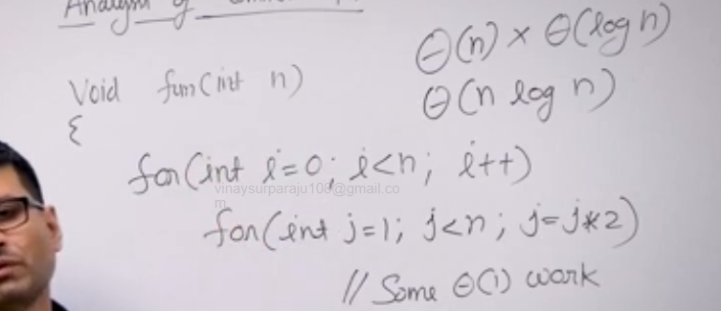

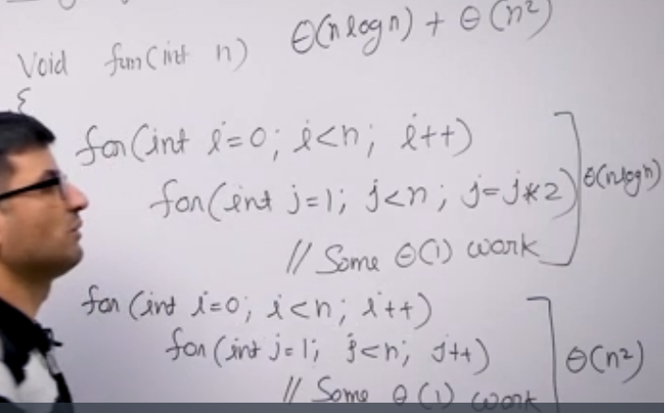

Analysis of recursion:

Recursive Tree method –

We divide recursion into 2 parts:

1. Non recursive
2. Recursive

We write non-recursive part as root of tree and recursive parts as children

We keep expanding children until we see a pattern.

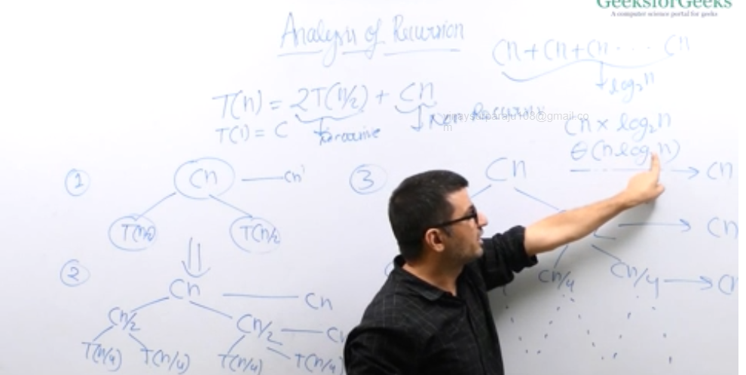

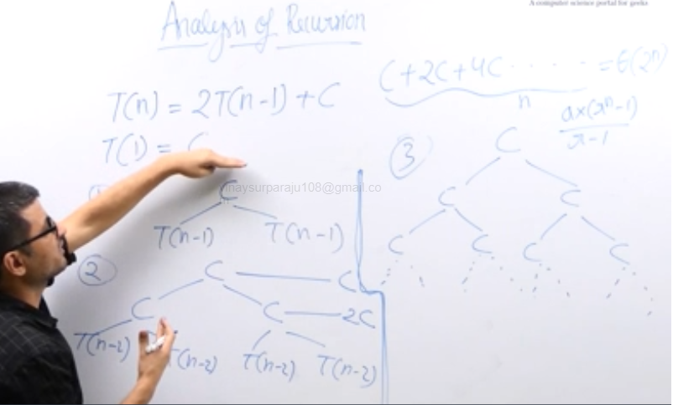

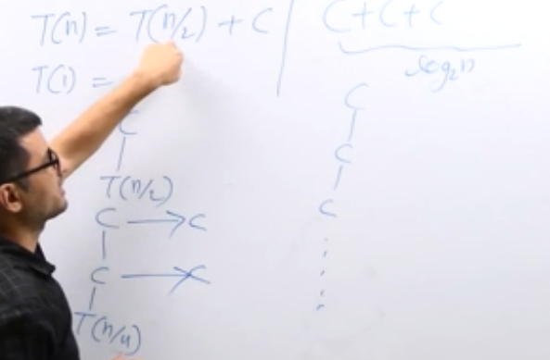

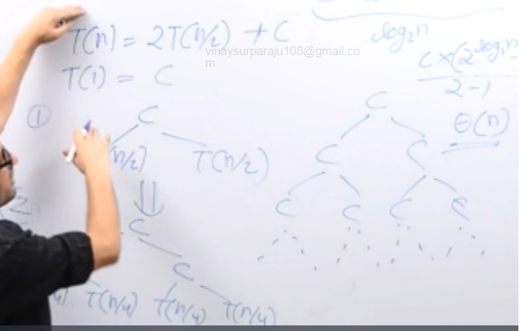

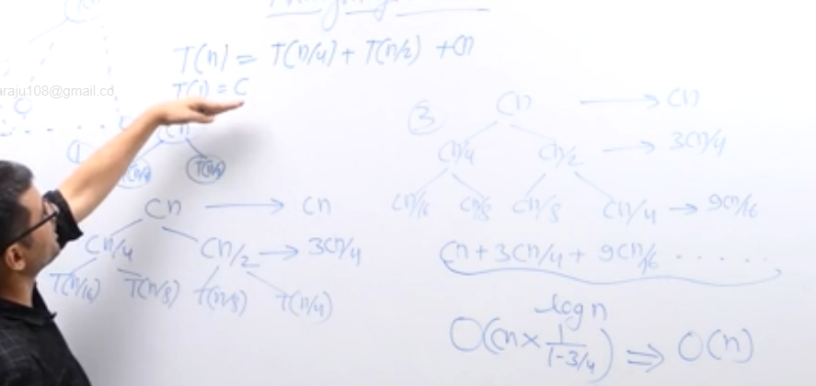

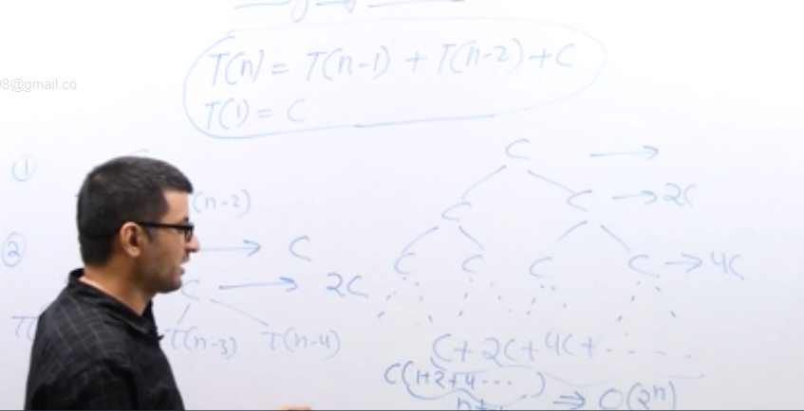

Space Complexity:

Order of growth in terms of memory space(RAM) size in terms of input size

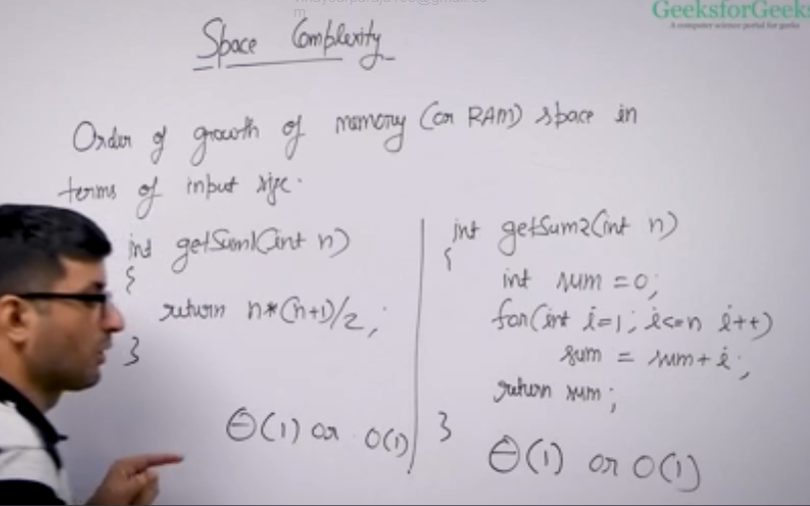

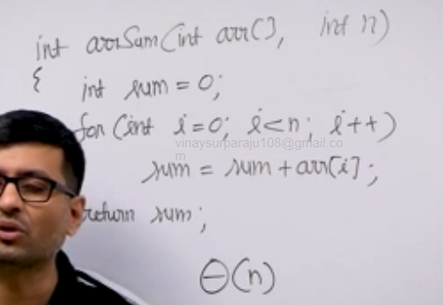

Auxiliary space –

Order of growth of extra space or temporary space in terms of input size.

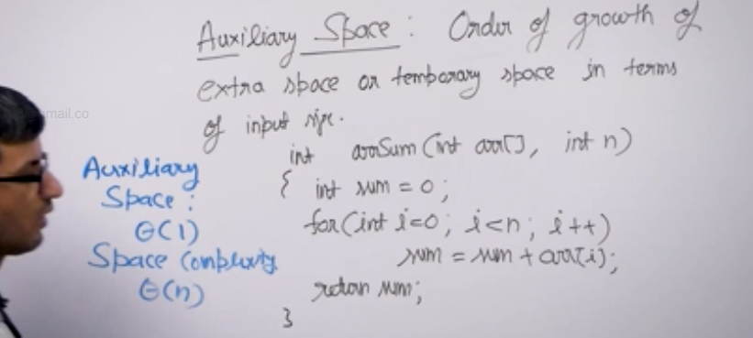

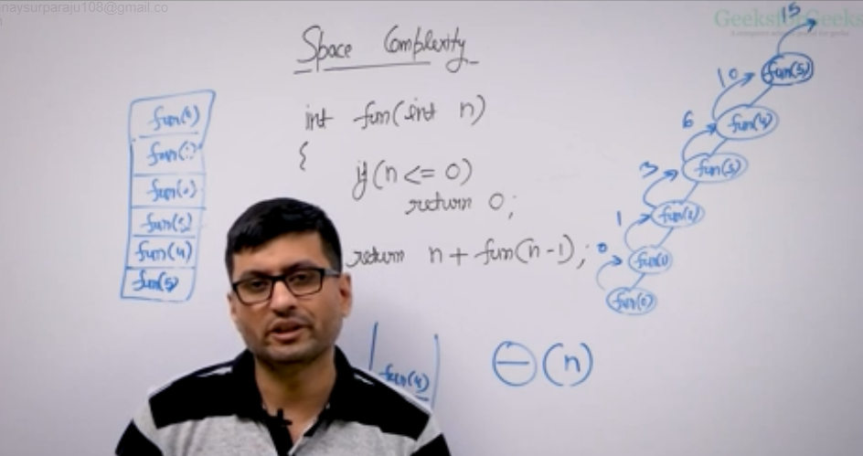

For recursive tree, auxiliary space is always equal to height of the tree i.e., max length of root to leaf path

